# Practical-3

**Problem Statement** - SQL Queries – all types of Join, Sub-Query and View:Write at least10 SQL queries for suitable database application using SQL DML statements: all types of Join ,Sub-Query and View

# Code : (Joins)

CREATE TABLE students ( student_id INT PRIMARY KEY, name VARCHAR(50),

age INT,

gender VARCHAR(10), department VARCHAR(50)

);

CREATE TABLE courses ( course_id INT PRIMARY KEY, course_name VARCHAR(100), department VARCHAR(50)

);

CREATE TABLE enrollments ( enrollment_id INT PRIMARY KEY, student_id INT,

course_id INT,

FOREIGN KEY (student_id) REFERENCES students(student_id), FOREIGN KEY (course_id) REFERENCES courses(course_id)

);

INSERT INTO students (student_id, name, age, gender, department) VALUES

(101, 'John Doe', 20, 'Male', 'Computer Science'),

(102, 'Alice Smith', 21, 'Female', 'Information Technology'), (103, 'Bob Johnson', 22, 'Male', 'Mechanical Engineering');

INSERT INTO courses (course_id, course_name, department) VALUES

(201, 'Database Management Systems', 'Computer Science'), (202, 'Operating Systems', 'Computer Science'),

(203, 'Data Structures', 'Information Technology');

INSERT INTO enrollments (enrollment_id, student_id, course_id) VALUES

(1, 101, 201),

(2, 102, 202),

(3, 103, 203),

(4, 101, 203);

SELECT s.name, c.course_name FROM students s

INNER JOIN enrollments e ON s.student_id = e.student_id INNER JOIN courses c ON e.course_id = c.course_id;

SELECT s.name, c.course_name FROM students s

LEFT JOIN enrollments e ON s.student_id = e.student_id LEFT JOIN courses c ON e.course_id = c.course_id;

SELECT c.course_name, s.name FROM courses c

RIGHT JOIN enrollments e ON c.course_id = e.course_id RIGHT JOIN students s ON e.student_id = s.student_id;

SELECT s.name, c.course_name FROM students s

FULL OUTER JOIN enrollments e ON s.student_id = e.student_id FULL OUTER JOIN courses c ON e.course_id = c.course_id;

# Output

* 1. **INNER JOIN**

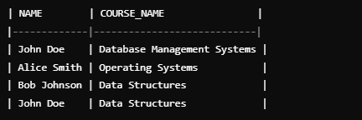

# LEFT OUTR JOIN



* 1. **RIGHT OUTER JOIN**



# FULL OUTER JOIN

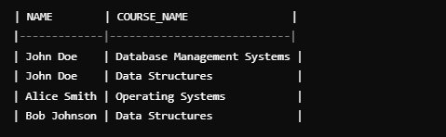

* **Code : (Sub Query & View)**

SELECT s.name FROM students s

WHERE s.student_id IN ( SELECT student_id FROM enrollments GROUP BY student_id

HAVING COUNT(course_id) > 1

);

SELECT s.name FROM students s WHERE NOT EXISTS (

SELECT 1

FROM enrollments e

WHERE e.student_id = s.student_id

);

CREATE VIEW student_courses AS

SELECT s.name AS student_name, c.course_name FROM students s

JOIN enrollments e ON s.student_id = e.student_id JOIN courses c ON e.course_id = c.course_id;

# Output :

**1. Sub Query 1 2. Sub Query 2**



# 3. View

